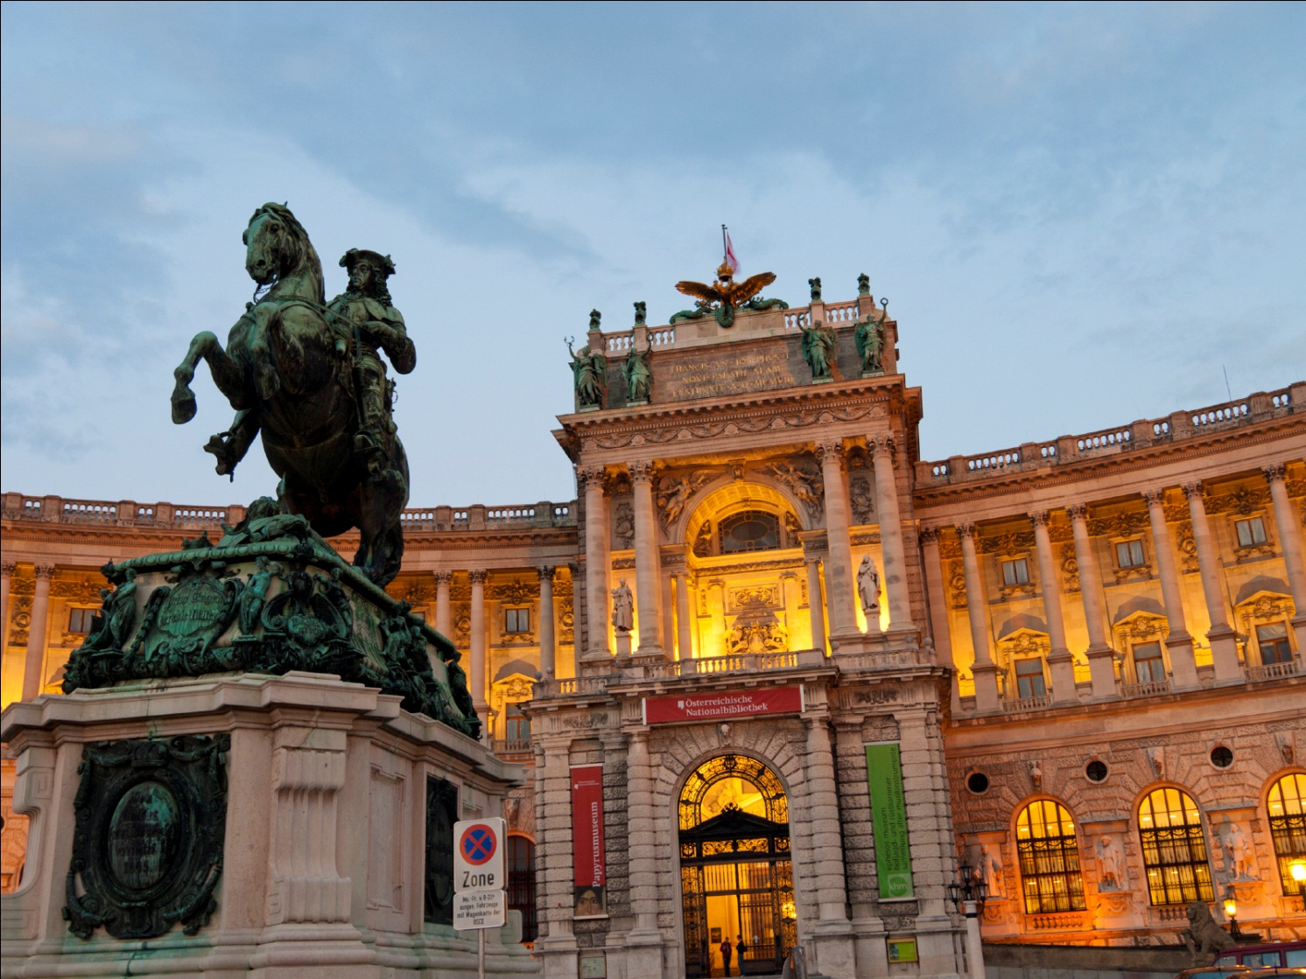
20th ESGENA Conference
15-17 October 2016

Hosted by the Austrian Society of Endoscopy Nurses and Associates (IVEPA)
In Conjunction with the
24th United European Gastroenterology Week

In Vienna, Austria

Further Information:
www.ueg.eu/week/esgena/
Important Deadlines
Submitting Abstracts May 31, 2016
Early registration May 12, 2016
Late Registration September 8, 2016

Word of Welcome

Dear colleague,

On behalf of ESGENA and the Austrian Society of Endoscopy and Gastroenterology Nurses and Associates (IVEPA), it is our great pleasure to invite you to the 20th ESGENA Conference which will be held during the 24th United European Gastroenterology Week, October 15-17, 2016 in Vienna, Austria.

ESGENA will celebrate its 20th Anniversary in Vienna. Since its foundation in Berlin in 1996, ESGENA has established close co-operation with more than 40 countries within Europe and overseas. ESGENA provides an excellent platform for strong networking and the exchange of information. Educational structures include the development of curricula, standards and guidelines as well as the establishment of clinical grants for individual nurses.

The Conference in Vienna is a good chance to reflect on the recent developments of the society and to discuss cutting-edge ideas. The jubilee also invites you to discuss new projects and the advancement of the profession with experts.

The ESGENA conference is also an excellent opportunity to meet colleagues from different countries. The exchange with nurses from all over the world combined with the opportunity to attend the medical programme of the UEG Week ensures the ESGENA conference is an exceptional educational event.

The three day ESGENA conference will include state-of-the-art lectures, free papers & posters, lunch sessions,
several workshops with hands-on training and live transmissions covering current topics in Gastroenterology
and Endoscopy.

We hope to welcome you to the 20th ESGENA Conference in October 2016 in Vienna, Austria.

Jayne Tillett, President of ESGENA
Anita Beyer, President of IVEPA

10 reasons to attend the ESGENA Conference
- World class platform for interaction
The ESGENA conference is a premier venue for nurses to present their experiences, studies and projects.
- Platform for networking with peers
The ESGENA conference is a unique venue for expanding your professional network.
- Scientific variety
The conference includes state-of-the-art lectures, free papers & posters, lunch sessions, workshops with hands-on training and live transmissions. Interesting topics in Gastroenterology and Endoscopy will ensure a truly global context.
- Emphasis on Interactivity
A full and varied programme will encourage networking and communication between the delegates – between both individual nurses and national groups.
- Awards for the best free paper and the best poster
The best free paper and poster awards promote best clinical practice and research in GE and endoscopy nursing.
- Advancement of professional status
The ESGENA conference provides a platform for professional development.
- Cooperation with other professional groups
The combined programme of UEG Week and the ESGENA conference reflects the multidisciplinary team work in clinical practice and research.
- Hands-on training
In combination with ESGE, ESGENA offers high quality hands on training in small groups to improve endoscopic skills.
- Workshop atmosphere
The ESGENA conference is geared towards group learning in a workshop atmosphere.
- Comprehensive industry exhibition
The extensive industry exhibition covers the entire spectrum of gastroenterology.

Call for Abstracts for 20th ESGENA Conference

ESGENA invites colleagues from Europe and from all over the world to present their experience, studies and projects at the 20th ESGENA Conference in October 2016 in Vienna, Austria. Participants wishing to submit abstracts can do so only in electronic format by sending a MS Word document with their abstract by e-mail to:
Ulrike Beilenhoff,
ESGENA scientific secretariat
Email: UK-Beilenhoff@t-online.de

Deadline for submitting abstracts: 31st May 2016

The authors will receive an official confirmation within 3-5 days after submitting their abstract. If authors do not get an official confirmation within 5 days, please send the abstract again to Ulrike Beilenhoff and a copy to the ESGENA technical secretariat: info@esgena.org.

General Information on Abstract Submission
Participants are invited to submit original scientific abstracts for oral or poster presentation.
Authors have to conform to the following guidelines for abstract submission. Those not conforming to the guidelines will not be considered for reviewing.
- Abstracts must be submitted in English and must be presented in English.
- Abstracts will be reviewed by a panel of experts and may be selected for oral or poster presentations, or may be rejected.
- Notification of acceptance (for oral or poster presentation) or rejection by the Scientific Programme Committee will be e-mailed to the presenting author by June 30, 2016.
- Detailed information, guidelines and recommendations for oral or poster presentation, as well as day, time and room will be sent in due time to duly registered presenting authors. The time allotted for each oral presentation will be 10 minutes, followed by 5 minutes of question time. During the poster round, authors of posters should also be prepared to answer questions in English.
- Accepted abstracts will be published in the ESGENA Abstract Book, in the ESGENA NEWS and on the ESGENA website.

The abstract should be typed as follows:
- Use font that is easy to read such as Arial, Times Roman, Helvetica or Courier fonts.
- The abstract must not be more than 500 words long or must not fill more than one A4 page, using type in 12-point font.
- A brief title should clearly states the nature of the investigation
- Abbreviations should, if possible, be avoided in the title, but may be used in the text if they are defined on the first usage
- The authors´ names (full first name, surname) and the institution (hospital, university, organization, city and country, e-mail and fax number) where the research was carried out, with the name of the presenting author underlined
- Use single line spacing
- Include tables if necessary
- The abstract should be as informative as possible
- The abstract should have a logical, scientific structure (introduction, mains & objectives, method, results, conclusion, summary, references, learning outcomes for audience)
- Statements such as „results will be discussed “ or „data /information will be presented “ cannot be accepted
- Please ensure that your abstracts do not contain any spelling, grammar or scientific errors, as it will be reproduced exactly as submitted
- The abstract should have a nursing relevant content and should add to existing knowledge.
- The abstract should have a minimum of 2 relevant References
- The abstract should state 2 things the delegates could learn from your presentation

How to prepare a well-written abstract

You can use the template to complete all sections

Scientific Abstract Template  (limit: 500 words or one A4 page) - Please complete ALL Sections | Explanatory Notes  When completed, and before submission – delete this column
Title | 10 – 12 words that capture the relevance and essence of the research
Introduction / Background | - What has been investigated  - Why is the research important.  - Context of the study - has something similar already been done and how the presented work differs
Aims / Objectives | - The purpose of the RESEARCH / project– not of the abstract!  - Providing a brief synopsis  - Hypothesis, question or concept underpinning the research.
(Research) Methods *  Please indicate which methodology you have used and delete non-applicable methods:  - Randomized Controlled Trial (Intervention)  - Meta-Analysis  - Systematic Review  - Cohort Study (Prediction)  - Qualitative Research Studies (Exploration)  - Service / Program Evaluation  - Audit  - Case Report  - Other: state which | - Should describe HOW the AIMS of the research were achieved.  - What the research/project involved - for example:  * Short description of the study design  * Underpinning theoretical or conceptual frameworks,  * Sampling technique(s) used, e.g. qualitative or quantitative,  * Retrospective or prospective  * Method of data collection: e.g. review, surveys, focus groups, patient cohorts etc.  * Sample size, criteria for selection and exclusion,  * Randomised or non-randomised.  * Type / method(s) of data analysis (tests)  * Statistical or interpretative analysis software programs used (GENERIC name of the software)  * If applicable: state if Ethics Approval was obtained.
Findings / Results | What the research discovered  - Synopsis of the findings of the study, using key data to demonstrate the outcomes.  - Avoid simply citing data, particularly in quantitative studies.  - State statistical significance (quantitative studies)  - Synthesis of the data and how it answers your research question.  NEVER submit an abstract without results,
Summary and Discussion | - Provide a short explanation of HOW the findings relate to the AIMS,  - present EVIDENCE of the findings from your METHODS (to support the implications of your study = conclusions)  - Critically define any weaknesses / strengths identified in your data
Conclusion | What the research implies  - IMPLICATIONS of the findings and  - how they ADD to the existing knowledge
Learning Outcomes + Relevance to Nursing Practice | Relevance to Nursing and how the findings can be used/applied in Clinical Practice

Registration fees for the ESGENA conference

Registration | by May 12, 2016 | by September 8, 2016 | after September 8, 2016
ESGENA Conference | € 185 | € 200 | € 250

- It is essential that nurses bring a copy of their professional standing or similar identification to the conference registration desk in order to prove their status (confirmation by employer, proof of education or registration as a nurse).
- If you would like to register up to 10 delegates, please register each person individually.

Registration includes
- Admission to all ESGENA scientific sessions and workshops (Saturday - Monday)
- Admission to the UEG Week scientific sessions (Monday)
- Admission to the UEG Week poster and technical exhibition (Monday)
- Admission to the ESGE Learning Area (Saturday - Monday)
- Admission to the Ultrasound Learning Centre (Saturday - Monday)
- Unlimited use of Vienna public transportation system (ticket is valid from Saturday through Monday).
- Congress materials (final programme, ESGENA abstract book, etc.)
- Coffee breaks and lunches (Saturday - Monday)

- If nurses are interested to attend the UEG Week on Tuesday and Wednesday, please contact Ulrike Beilenhoff (ESGENA Scientific Secretatry, email: UK-Beilenhoff@t-online.de

General Information
ESGENA Conference Registration
UEG Week Official Registration Partner
Mondial Congress & Events
Operngasse 20b, 1040 Vienna, Austria
F +43 158 80 40
uegweek.registration@mondial-congress.com
Ulrike Beilenhoff
c/o ESGENA Scientific Secretariat
Ulm, Germany
uk-beilenhoff@t-online.de
Rietta Schönberger
c/o ESGENA Technical Secretariat
Manching, Germany
info@esgena.org

You may also contact:
- For ESGENA: www.esgena.org
- Conference: www.ueg.eu/week

Programme Overview

SATURDAY, October 15, 2016

Lecture Halls |  |  |  |  | ESGE Learning Area
Hall | Room M | Room 1.86 | Room L-7 | Room L-8
09.00-10.30

UEG Week
Post Graduate Training Programme

10:30-11:00 |  | Coffee Break
11.00-13.00

UEG Week
Post Graduate Training Programme

13:00-14:00 |  | Lunch Break
14.00-16.30  UEG Week  Post Graduate Training Programme | 14.00-15.30  Workshop 1  Endoscopic Techniques  Organised by Olympus | 14.00-15.30  Workshop 2  Reprocessing of Endoscopes  Organised by BHT & Chemische Werke Dr. Weigert | 14.00-15.30  Workshop 3  Endoscopic Techniques  Organised by Boston Scientific | 14.00-15.30  Workshop 4  How to build a new team?  Organised by ESGENA & IVEPA | 14.00-15.30  Workshop 5  Hands-on-training on biosimulators:  Upper GI bleeding  ERCP  Colonoscopy
 |  | Coffee Break
 | 16.00-17.30  Workshop 6  Hygiene & Infection Control  Organised by Olympus | 16.00-17.30  Workshop 7  Electro surgery -Prevention of complication  Organised by  Erbe | 16.00-17.30  Workshop 8  To be announced  Organised by Industry | 16.00-17.30  Workshop 9  To be announced  Organised by ESGENA & IVEPA | 16.00-17.30  Workshop 10  Hands-on-training on biosimulators  Upper GI bleeding  ERCP  Colonoscopy

Programme Overview

SUNDAY, October 16, 2016
Hall G | Hall K | Poster Area | ESGE Learning Area
07.45-08.45

ESGENA Annual General Assembly

09:00-10.30  Session 1  Free Paper I | 09:00-10.30  Session 2  IBD
10:30 – 11.00  Coffee | 10:30 – 11.00  Coffee | 10:30-11:00  Poster Round I | ----
11.00-13.00  Session 3  Free Paper II | 11.00-13.00  Session 4  Education & Management |  | 11.00-12.30  Workshop 11  Hands-on-training on bio simulators  Upper GI Bleeding  ERCP
13:00-14:00  Lunch | 13:00-14:00  Lunch
13:30-15:00  Lunch Session 1  New Techniques & Developments on GE Endoscopy | 13:30-15:00  Lunch Session 2  New Techniques & Developments on Hygiene & Infection Control | 13:30-15:00  Poster Round II | 14.00-15.30  Workshop 12  Hands-on-training on bio simulators:  ERCP  Colonoscopy
15:00-16:30  Session 5  Around the Oesophagus | 15:00-16:30  Session 6  Quality Assurance | ----
16:30-17.00  Coffee | 16:30-17.00  Coffee |  | -----
17:00-18:30  Session 7  Hygiene Updates | 17:00-18:30  Session 8  Complication & Adverse Events | ----
Programme Overview

MONDAY, October 17, 2016

Hall F 1

08.30-10:00

Best Free Paper and Best Poster Award

ESGENA 20th Anniversary Achievements & Future

Invitation to next conferences

10:30 – 11:00
Coffee
Visit of Exhibition
ESGE Learning Area
UEGWeek Sessions

12:30-14:00
Lunch
Visit of Exhibition
ESGE Learning Area
UEGWeek Sessions

15.30-16.00
Coffee
Visit of Exhibition
ESGE Learning Area
UEGWeek Sessions

ESGENA-Scientific Programme on October 16, 2016

ESGENA Annual General Assembly

07:45-8:45 | Hall G

SESSION 1: Free Paper I

09:00-10:30 | Hall G
 | - Welcome
 | - 5 free papers will be presented

SESSION 2: Inflammatory Bowel Disease (IBD)

09:00-10:30 | Hall K
 | - Welcome
 | - Living with IBD – “And suddenly I was a patient”
 | - Vaccination and IBD
 | - Hypnotherapy in groups of patients with IBS and IBD
 | - Psychosocial health and health related quality life among children and young adults with inflammatory bowel disease

Posterround I

10:30-11:00 | Poster area in front of Hall G
 | - Posters will be presented in an interesting poster round

SESSION 3: Free Paper II

11.00-13:00 | Hall G
 | - 6 free papers will be presented

SESSION 4: Education & Management

11:00-13:00 | Hall K
 | - Presentation of major sponsor
 | - The increasing role of the nurse in the higher educated field of health care professionals and ‘ RN4CAST ’.
 | - European Accreditation Network (ENA) Improving the quality of educational activities for health professionals in Europe
 | - Nurses percepcion of the research work - application in daily practice
 | - Lean Management in Endoscopy
 | - Establishing an Endoscopy Unit in Tibet – A report

Workshop 11: Hands-on Training on Bio Simulators

11:00-12:30 ESGE Learning Area

Hands-on training on bio simulators (pig models) under the supervision of highly experienced tutors.
Participants will have the opportunity to perform endoscopic techniques on the following topics:
- Colonoscopy
- ERCP
As participation will be limited, registration will be treated on a first-come-first-served basis.
Ticket will be available onsite only – at the entrance of the ESGE Learning Area.

Posterround II

13:30-15:00 | Poster area in front of Hall G
 | - Posters will be presented in an interesting poster round

Lunch Sessions

The two lunch sessions are organised by ESGENA

13:30-15:00 | Hall G
- ESGENA lunch Sessions will combine lectures with hands-on training on:
  - New Techniques & Developments on GE Endoscopy
  - Hygiene & Infection Control

Workshop 12: Hands-on Training on Bio Simulators

14:00-15:30 ESGE Learning Area

Hands-on training on bio simulators (pig models) under the supervision of highly experienced tutors.
Participants will have the opportunity to perform endoscopic techniques on the following topics:
- Colonoscopy
- ERCP
As participation will be limited, registration will be treated on a first-come-first-served basis.
Ticket will be available onsite only – at the entrance of the ESGE Learning Area.

SESSION 5: Around the Oesophagus

15:00-16:30 | Hall G
 | - Presentation from Major Sponsor
 | - Endoscopic treatment in Barretts
 | - Eosinofiele oesophagitis
 | - Self Dilatation – a special class for patients
 | - Presentation from Major Sponsor

SESSION 6: Quality Assurance

15:00-16:30 | Hall K
 | - Presentation from Major Sponsor
 | - New ESGE Statement: Requirements and standards facilitating quality improvement for reporting systems in gastrointestinal endoscopy
 | - Electronic assessment and documentation of sign-in , team-time-out and sign-out
 | - 20 years’ experience with nurse endoscopists – advantages, challenges & limitation
 | - Presentation from Major Sponsor

SESSION 7: Hygiene updates

17:00-18:30 | Hall G
 | - Presentation from Major Sponsor
 | - How safe are our duodenoscopes?
 | - How to manage outbreaks in Endoscopy
 | - Storage of endoscopes – How do time frame and conditions matter
 | - Quality criteria for washer disinfectors – the users perspective

SESSION 8: Complication & Adverse Events

17:00-18:30 | Hall K
 | - Presentation from Major Sponsor
 | - Managing a GI Bleeding service – the nurse manager´s perspective
 | - Emergency Endoscopy – when, where, by whom?
 | - Breaking bad news - different approaches in European countries
 | - Presentation from Major Sponsor

ESGENA-Scientific Programme on October 17, 2016

SESSION 9: ESGENA 20th Anniversary

08:30-10:00 | Hall F1
- Best Free Paper and Best Poster Awards
The winner of the best free papers – oral presentation and the best poster presentations - will be announced. Presenting authors are requested to attend this session. ‘
PENTAX Medical supports the ESGENA Free Paper and Poster Award

 | - The Microbiom and Gastrointestinal diseases
 | - Endoscopy over the last 20 years – the multidisciplinary approach
 | - The role of the endoscopy Nurses – achievements and the future
 | - Invitation to the next ESGENA Conference 2017 in Barcelona

